Wedding of

….

and

…

Date and Time

St Andrew’s Church
On the Green
Haughton-le-Skerne
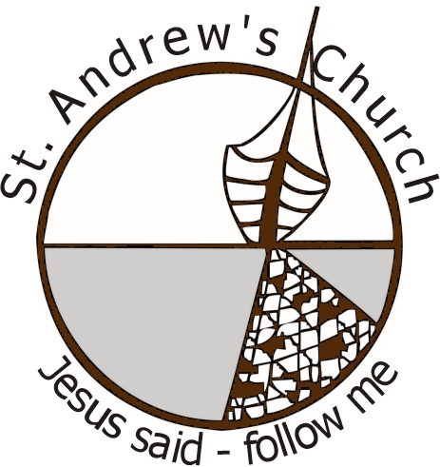

Bridal Procession R.Wagner (from Lohengrin)

Welcome and Introduction
The grace of our Lord Jesus Christ,
the love of God,
and the fellowship of the Holy Spirit be with you
and also with you.

This prayer is said together
God of wonder and of joy:
grace comes from you,
and you alone are the source of life and love.
Without you, we cannot please you;
without your love, our deeds are worth nothing.
Send your Holy Spirit,
and pour into our hearts
that most excellent gift of love,
that we may worship you now
with thankful hearts
and serve you always with willing minds;
through Jesus Christ our Lord. Amen.

Hymn:

Preface and Declarations
Will you, the families and friends of …. ,
support and uphold them in their marriage
now and in the years to come?
We will.

Readings
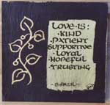
read by
read by

The Marriage Vows and the Exchange of Rings

The Blessing

Signing of the Register

The Prayers
Lord of life and love:
hear our prayer.


The Lord's Prayer

As our Saviour taught us, so we pray
Our Father in heaven,
hallowed be your name,
your kingdom come,
your will be done,
on earth as in heaven.
Give us today our daily bread.
Forgive us our sins
as we forgive those who sin against us.
Lead us not into temptation
but deliver us from evil.
For the kingdom, the power,
and the glory are yours
now and for ever. Amen.
Hymn:

Wedding Procession
F.Mendelssohn (from A Midsummer Night’s Dream)

